**PYTHON ASSIGNMENT – 6**

**Q1. Write a Python program to read a file line by line and store it into a list.**

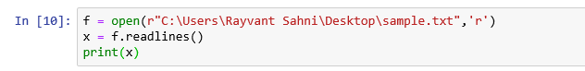

**Q2. Write a Python program to read a file line by line store it into an array.**

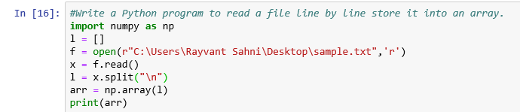

**Q3.** **Write a Python program to read a random line from a file.**

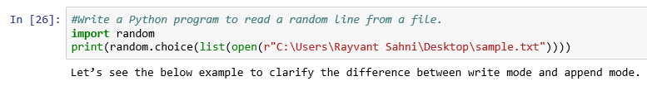

**Q4. Write a Python program to combine each line from first file with the corresponding line in second file**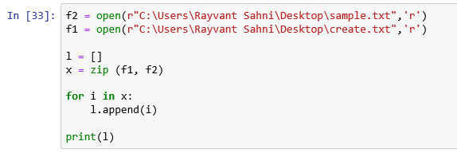

**Q5. Write a Python program to generate 26 text files named A.txt, B.txt, and so on up to Z.txt.**

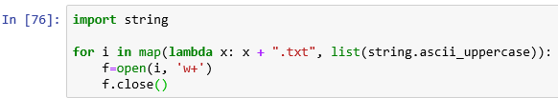

**Q6. Write a Python program to create a file where all letters of English alphabet are listed by specified number of letters on each line.**

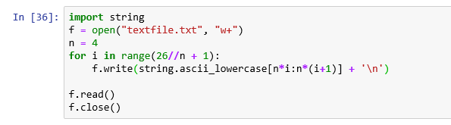

**Q7. #### MAIN TASK ####**

**- To scrap data from worldometer example: INDIA Data and run it on live mode.**

**- Print Additionally total number of Coronavirus Cases, Deaths, Recovered.**

